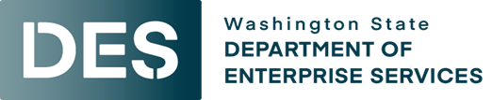

State of Washington
Contracts and Procurement Division
Department of Enterprise Services
P.O. Box 41411
Olympia, WA 98504-1411

Solicitation Amendment
Solicitation No.: 25-0001
Amendment No.: Two
Effective Date: August 20, 2026

Amendment No. Two
to
Solicitation No. 25-0001
Roll Stock

This Amendment (“Amendment”) to Solicitation No. 25-0001 is effective immediately. Amended Exhibit C is required to be submitted with proposals if specifications are amended during the Question and Answer period. All other terms, conditions, and specifications remain unchanged.
P U R P O S E
The Purpose of this amendment is to capture the following changes:
- The Question and Answer period is reopened. The period will run from August 20, 2026 to September 10, 2026. The purpose of reopening the Question and Answer period will be to further develop product specifications so they can be applied to any manufacturer of Roll Stock.
- The closing date for this solicitation will be September 30, 2026.

PRIOR AMENDMENTS

- The closing date for this solicitation was extended to September 1.

Any communication regarding this amendment must be addressed to the Procurement Coordinator listed below.

Sean Santoro
360-407-8167
Sean.santoro@des.wa.gov

