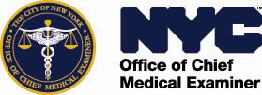
Department of Health & Mental Hygiene
OFFICE OF CHIEF MEDICAL EXAMINER
421 East 26th Street, NEW YORK, NY 10016

NON-COMPETITIVE PURCHASE FROM M/WBE VENDORS

AGENCY PIN: 26R1007KC PASSPORT EPIN: 81626Y0819

TO ALL PROSPECTIVE VENDORS:

This solicitation is being made pursuant to the M/WBE Noncompetitive Small Purchase Method, Section 3-08 of the New York City Procurement Policy Board (PPB) Rules, this procurement is exclusively for the City Certified Minority and Woman Owned Business (M/WBEs). Contracts awarded under this method may not exceed $ 1,500,000.00 inclusive of any and all change orders, overruns, amendments, renewals, and extensions.
The City of New York Department of Health and Mental Hygiene, Office of Chief Medical Examiner (OCME) is soliciting from Minority and/or Women-owned Enterprises (“M/WBE Vendors”) who are authorized vendors that meet the need for the agency. This request is for a One Time Purchase Agreement for SCISSOR LIFT TABLES (1000 LBS CAPACITY) or Equivalent where all goods must be delivered on or before June 30th, 2026, and the indicated item(s) in this solicitation is not to exceed $100,000.
Please submit your proposal by both acknowledging the receipt of the RFX in the Acknowledgement Tab and completing your response in the Manage Responses Tab. Vendor resources and
materials can be found at the link below under the Finding and Responding to RFx heading.

Delivery Address: 599 Winthrop Street Brooklyn, Ny 11203 & 160-15 82nd Dr, Jamaica NY 11432 (Unless otherwise agreed upon by both parties)

The awarded M/WBE Vendor is advised that OCME is not responsible for paying for deliveries which exceed the total amount of any this solicitation or for any unauthorized deliveries.

The terms of this RFI: between April 20th, 2026 – June 30th, 2026

See specifications below

The award will be made for the item(s) indicated in this solicitation. The award will be made to the vendor offering the lowest aggregate price for the following item (s) indicated in this solicitation not to exceed
$100,000.
Payment will be made in accordance with the NYC Procurement Policy Board (PPB) Rules, Section 4-06.
Need help or have a question? Submit an inquiry to the MOCS Service Desk
Link: https://www1.nyc.gov/site/mocs/systems/passport-user-materials.page

# 26R1007KC Page 1 of 2 04/01/26
SCISSOR LIFT TABLE SPECS:
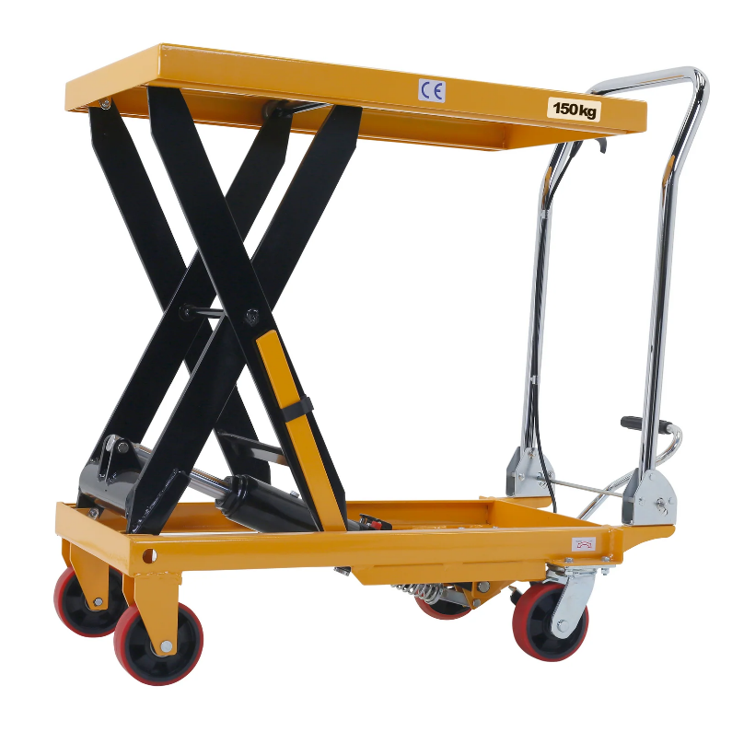
*PHOTO IS NOT TO SCALE – SEE SPECS BELOW

Model #: SL60
Description:10P PORTABLE SCISSOR LIFT
TABLE (1000 LBS. CAPACITY)
Platform: 27" w x 80"l
Roller Conveyor: mounted to the unit with 24"
bfr x 80rs" l rollers mounted on 12" center
with1.9" dia rollers
Over Center Lock: mounted on the front and
rear rollers
Captured Rollers: two sections top and
bottom
Base: 24"w x 80"l
Portable Package: includes two 6" swivel
casters and two 6" rigid rollers also include a
floor lock and removeable push handle
Low Height: 12"
Travel: 60"
Total: 72"
Colour
Power: D/C 12v includes a built-in charger
and hand controls
Quantity: 3

# 26R1007KC Page 2 of 2 04/01/26

