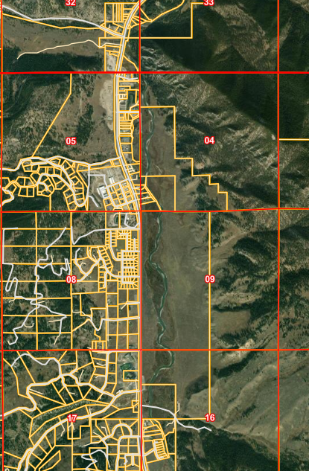
Start of project MP45
End of project MP 47.9

